Initial functions 初始化功能

Category list
Category lis
Category no. [h] | Category | Description
00 | CONFIG | External pin settings
01 | GPIO_CTRL | Port driver settings
12 | EVR | EVR settings
13 | ADJ | Adjustment modes: Pre-white balance, mechanical iris, static defection, shading 预白平衡，机械光圈，静态坏点，阴影校正
14 | ADJ_Z | Adjustment mode settings
15 | AE | Exposure control
16 | AE_FRM | Exposure control settings
17 | AWB | White balance control
18 | AWB_FRM | White balance control settings
19 | OPD_FRM | OPD
1A | PICT | Basic settings: Dynamic defect compensation, negative/positive, color  adjustments, Day Night, clamp  基本设定：动态坏点校正，正负片转换，颜色调整，Day/Night模式
1B | PICT_GAIN | Gain-tracking, brightness-tracking, thresholds, aperture compensation, NR, filters, clipping, chroma, Day Night
1C | PICT_GAMMA | Gamma
1D | PICT_LMT | Linear matrix
1E | PICT_HUEGAIN | Hue Gain adjustments
1F | PICT_VATR | ATR-EX
21 | MASK | Privacy masks
22 | OSD | OSD(On Screen Display)
24 | COMMON | Common information
25 | AE_OPD_OUT | AE OPD output
26 | AWB_OPD_B_OUT | AWB OPD output
27 | AWB_OPD_G_OUT | AWB OPD output
28 | AWB_OPD_R_OUT | AWB OPD output
29 | AF_OPD_OUT | AF OPD output
2A | SOUTRAM | Sensor selection, clock, frame rate, outputs
43 | ISP_PRE_PG | Test pattern output
46 | ISP_PRE_SHD | Shading compensation
5C | ISP_POST_VIF YUV | output

Basic functions 基本功能

Exposure control

Exposure control mode switching
Exposure control has the following modes: AE, long AE, gain-designated mode, hold and the ME user modes (user settings 0 to 3). By setting the AEMODE register below, the exposure control mode can be switched.
曝光控制模式由以下几种：AE，long AE，gain设定模式，AE hold模式和手动Exposure模式(0~3四种用户设定)。
Offset Address | Bit | Bit name | Default Value | Description
0000[h] | 6:0 | AEMODE | 0[h] | AE mode 0: AE 1: Long AE  2: AE hold 3: Gain-designated  4: USER0 5: USER1 6: USER 7: USER3

Normal AE mode
When 0[h] is selected as the AEMODE register setting, the normal AE mode is established. In this AE mode, the gain and exposure time are automatically adjusted so that the images have the appropriate brightness. Under the darkest conditions, the digital gain and analog gain are set to the maximum values, and the shutter time is set to the maximum exposure time. When it gradually becomes lighter, the digital gain is reduced, and it is set to the minimum value. When it becomes even lighter, the analog gain is reduced, and is set to the minimum value. When the gain control is exceeded, the shutter time is reduced, and finally it is set to the minimum exposure time. Furthermore, in the normal mode, it is not possible to extend the exposure time beyond the frame rate. This level is referred to as the maximum exposure time.
通过设定AEMODE寄存器值为0以建立正常AE模式。在最暗的环境下，digital gain和analog gain调整至设定的最大值，shutter time也调整至设定的最大值。当光线逐渐变亮一些，digital gain减少到最小值。然后光线进一步加强的时候analog gain在接着减少至最小值，当光线一直在变强，shutter time减少，最后减少到最小的exposure time。在正常的AE模式下，exposure time不会大于帧输出的时间，且帧的时间就是exposure time的最大值。
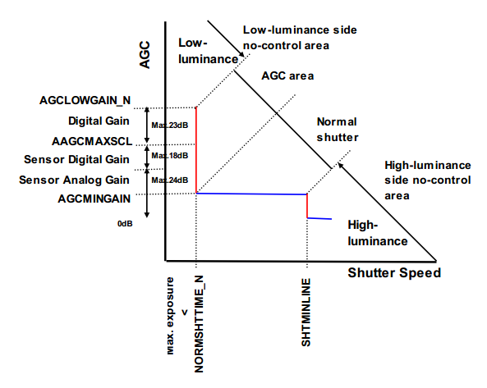
In the low- and high-luminance side no-control areas, the actual gain and shutter time do not change, and the values are not reflected to the image.
在低光和高亮并且到达了no-control的环境中，实际的gain和shutter不会再改变。

Specifying the normal AE area and gain
Specify the range of gain and shutter time to correspond to normal AE. Refer to the “parameter list”, for It is possible to change this default value.
Offset Address | Bit | Bit name | Default Value | Description
000E[h] | 15:0 | NORMSHTTIME_N | FFFF[h] | Normal AE maximum shutter time 最大shutter time
000C[h] | 7:0 | SHTMINLINE | 1[h] | Minimum shutter time 最小shutter time
0010[h] | 15:0 | AGCLOWGAIN_N | 8C[h] | Normal AE maximum gain 最大gain
002C[h] | 15:0 | AAGCMAXSCL | 1C00[h] | Sensor maximum gain sensor最大的gain
000D[h] | 7:0 | AGCMINGAIN | -[h] | Minimum analog gain 最小analog gain

Normal AE maximum shutter time
Normal AE maximum shutter time NORMSHTRIME_N is t he register used to set the maximum exposure time. 0.1 milliseconds are used as the unit. The maximum exposure time in the shutter area is the frame rate. Even when a value exceeding the frame rate is set, it will be limited. To select a longer exposure time setting, establish the settings described in section “9.1.6 Long AE mode.”
NORMSHTRIME以0.1ms为单位。

Minimum shutter time
Minimum Shutter time SHTMINLINE is the register used to set the minimum exposure time. This value is the number of line.
Minimum shutter time calculation formula:
Shutter time = Number of clocks per 1V x Setting value / Sensor readout clock frequency (CISCLK_P/M or DCK) -
= coefficient / sensor readout frequency
Refer to the sensor specification about the coefficient.
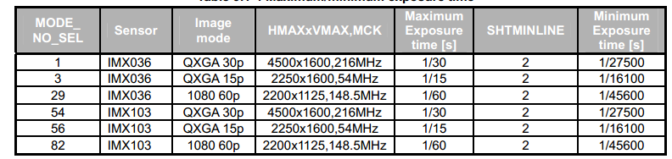
The table below lists the typical maximum and minimum exposure time values.
以IMX036 1080 60P为例，通过上图我们可以算出IMX036的=2200 * 2/148.5*10^（-6）-1/45600 = 7.7x10^（-6）。所以coefficient = 1144。

Normal AE maximum gain
Normal AE maximum gain AGCLOWGAIN_N is the register used to set the maximum gain. This is the sum of sensor gain and DSP digital gain. A step of 0.3[dB] is used as the unit. At BA[h], the gain is approximately 56[dB].
正常AE下通过AGCLOWGAIN_N设定最大gain，其值为sensor的gain和DSP的gain之和，步进为0.3DB，值为0xBA时大约56DB。

Sensor maximum gain
Sensor maximum gain AAGCMAXSCL is the register used to specify the maximum analog gain(APGA) and digital gain(DPGA) of sensor.
通过AAGCMAXSCL 设定sensor里面的最大模拟gain和数字gain。
Setting = Sensor gain area (dB) / 1024x6.02
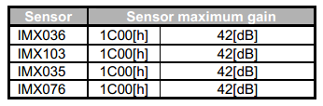
上图显示了各个sensor最大gain设置。
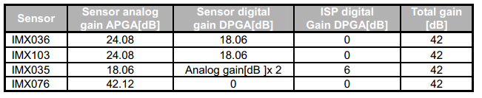
上图显示了各个sensor里面的analog gain和digital gain的值。

Minimum analog gain
Minimum analog gain AGCMINGAIN is the register used to specify the minimum gain value, that is to say, the minimum analog gain value of the sensor. A step of 0.3[dB] is used as the unit. The table below lists the minimum analog gains in the parameter file provided from Sony.
AGCMINGAIN是设定sensor的最小analog gain，步进为0.3DB。
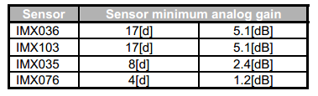
The sensor digital gain and analog gain for the IMX035 image sensor operate differently than for other sensors. When the analog gain has been set to more than 18[dB], the digital gain will be 18[dB] and the analog gain will be 0[dB]. The maximum gain of the sensor is 36[dB], and the DSP digital gain is approximately 6[dB].

Mechanical iris AE mode
In high-luminance environments when the light quantity cannot be adjusted even in the minimum shutter time or when the camera is to be used while the shutter time is fixed, the light quantity can be automatically adjusted by controlling the aperture of the mechanical iris.
The IT-N supports only the DC iris lens. It does not support the video iris lens.
IT-N支持DC iris lens，不支持video iris lens
The figure below shows the relationship between the lens aperture, shutter time and gain in the mechanical iris AE mode.
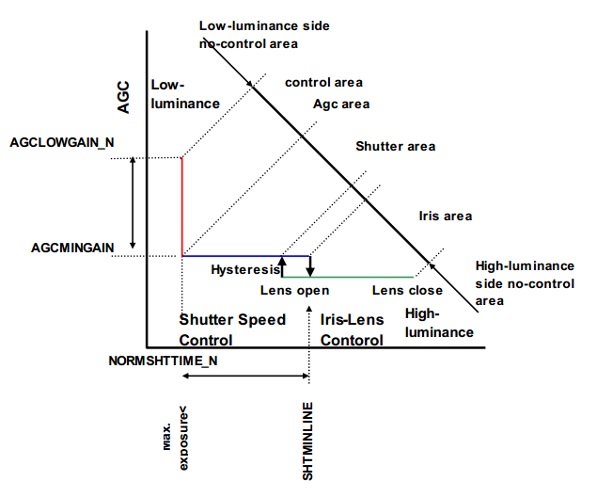
There is a hysteresis relationship between the mechanical iris aperture and shutter time. For this reason, once the mechanical iris is controlled, the lens aperture will open, and operation transfers to the normal AE control area only when the conditions which have been set continue to be satisfied.
如上图所示，在iris和shutter time之间有个滞后关系。这是因为一旦机械光圈被控制并被打开后，只有将AE操作转移到正常的AE控制区域才能使的整个控制过程让人感觉比较舒服。

Mechanical iris lens drive circuit机械光圈驱动电路
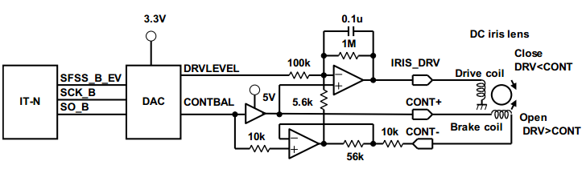
The figure below shows an overview of the mechanical iris drive circuit which is called the EVR. When SPI pin of the IT-N System and DA converter (DAC) are connected, DAC is controlled using SPI communication from the IT-N System, and the DRVLEVEL drive voltage used for control and CONTBAL reference voltage are generated. The CONTBAL reference voltage sets the intermediate level of the mechanical iris drive voltage range, and it is connected to CONT+ through the drive circuit. The IRIS_DRV voltage which drives the iris is the value obtained by amplifying DRVLEVEL and adding the CONTBAL reference voltage signal.
机械光圈控制电路英文简称为EVR，由IT-N通过SPI控制DAC芯片，然后由DAC产生的DRVLEVEL去控制iris和CONTBAL做为参考电压。CONTBAL设定为中间水平的机械光圈电压范围，然后连接至CONT+，驱动iris的电压值IRIS_DRV是通过 DRVLEVEL和 CONTBAL两个信号比较得到的。

Outline of mechanical iris AE adjustment
DAC is set and AEMODE is selected. Secondly before adjusting mechanical iris mode automatically, confirm that the mechanical iris lens is active. Refer to “ Mechanical Iris Operation Settings”. After that , the voltage level and coefficient can be automatically adjusted by executing ” Mechanical Iris Adjustment Mode.”
光圈自动化控制前需要配置一系列的参数。

Mechanical Iris AE Control Setting
The mechanical iris AE mode can be selected in combination with the AE mode. The normal AE mode, long AE mode, gain-designated mode or user mode can be selected among the AE modes available. It is also possible to control the mechanical iris in tandem with the flicker less mode.

Mechanical Iris Operation Settings
The following settings are made for mechanical iris operation settings: reference voltage, integral coefficient, differential coefficient, and proportional coefficient representing the basic operation setting. Finally, the settings of the transition into the normal AE control region is described。
需要设定的参数是：参考电压，积分系数，微分系数，比例系数这些基本的设定。

Mechanical Iris Reference Voltage
The register CONTROL_LEVEL represents the reference voltage for mechanical iris control.
Offset Address | Bit | Bit name | Description
001B[h] | 7:0 | CONTROL_LEVEL | Reference voltage for mechanical iris control
The reference voltage for mechanical iris control can be found using the equation given below. 参考电压计算公式：
Reference Voltage = (DC Iris Lens Open Voltage - Close Voltage) / 2

Example of the settings for Tamuron M12VG412 lens
When using the Tamuron M12VG412 the open voltage of lens is 3.0V. The close voltage is 0.5V. The reference voltage is 1.75V, halfway between the open and close voltage. The EVR DAC reference voltage which is incorporated into Sony's EVB is 3.3V, the bit width is 8 bits, and single-digit voltage is 0.0129V. As a result, the mechanical reference voltage is 135[d] (87[h]). Furthermore, the drive circuit of the mechanical iris incorporated into Sony’s EVB supports the specifications of lenses whose close voltage is lower than its open voltage and whose open voltage is 5V or less.
腾龙的M12VG412 镜头光圈open状态电压为3.0V，close状态的电压为0.5V，则依照公式，参考电压为open和close电压的之间值。支持open状态下低于5V的镜头光圈。

Proportional Coefficient, Integral Coefficient, and Differential Coefficient
The value resulting from subtracting the AE integrated brightness value from the AE reference value is the error value. The value resulting from multiplying the error value by the proportional coefficient is the mechanical iris drive voltage. When the image is bright, a negative voltage versus the CONTROL_LEVEL is applied to the mechanical iris drive voltage, causing the lens aperture to move toward closing. Because this reduces the light passing through the lens, the AE integrated brightness drops. When it drops below the level where there is an error, equilibrium is reached. The reverse operation results when opening the lens aperture.
Register MIRISKP stores the coefficient by which the AE error level is multiplied. The integral coefficient, given by MIRISTI, is set to stabilize control. The differential coefficient, given by MIRISTD, is set to improve control tracking and accuracy.
error value是AE统计亮度和参考亮度值的差。驱动电压是有error value和比例系数相乘的结果。当图像亮了，以CONTROL_LEVEL相比有一个反向的压差作用与iris driver，这样会导致iris缩小。这样使得图像亮度下降，最终达到一个亮度误差平衡范围。反之同理。
MIRISKP 就是error value的比例系数，MIRISTI为积分系数，微分系数名称为MIRISTD，微分系数的作用是改善控制轨迹的精确性。
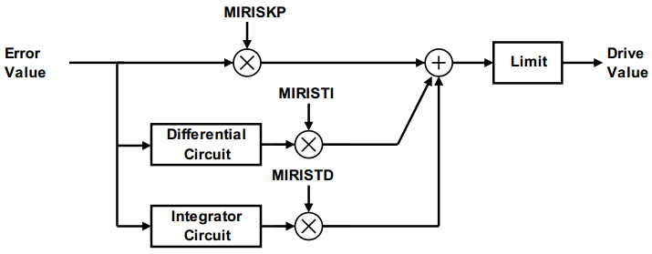
Offset Address | Bit | Bit name | Description
0018[h] | 7:0 | MIRISKP | Mechanical iris proportional coefficient
0019[h] | 7:0 | MIRISTI | Mechanical iris integral coefficient
001A[h] | 7:0 | MIRISTD | Mechanical iris differential coefficient
Use a differential coefficient of “0” to stabilize the image brightness level.
为了图像亮度的稳定性，微分参数设置为0。

Mechanical Iris Drive Limit
A limit can be placed on the absolute value of the difference between the maximum and minimum control values of the mechanical iris using the register MIRIS_SCL_LIMIT.
可以使用寄存器MIRIS_SCL_LIMIT去限制最大的iris和最小的iris值。

Offset Address | Bit | Bit name | Default Value | Description
00CE[h] | 7:0 | MIRIS_SCL_LIMIT | A00[h] | Absolute value of the difference between the maximum and minimum control values of the mechanical iris.
The larger this value, the wider the control range of the mechanical iris lens. Adjust while observing the brightness level.
值越大，iris控制调整的范围越大，可根据brightness适时调整。

Mechanical Iris Open Determination Setting
When the open status of a mechanical iris lens has continued for a specific period of time, control is transferred from the control region of the mechanical iris to the normal AE control region. However, it is not possible to detect the extent to which the mechanical iris is open or closed. The status is identified to be either open or non-open on the basis of the error amount and OPD value. When the absolute value of the negative error amount in the open direct ion is greater than the dead band, the count measurement is started. When a status exceeding the counter threshold value is maintained and the absolute value of the difference between the OPD integral value of the current frame and OPD integral value of two frames before is within the threshold value set using the OPDSHAKE register, control is transferred to the normal AE control region. Furthermore, if the mechanical iris is not connected, its status is always identified as open.
当打开一个机械光圈镜头的动作已经持续了一段特定的时间，AE的控制从iris控制转移到正常AE的区域控制。然后，系统是不能检测外接的iris是open还是closed。状态的判断是否open或是non-open基于error amount和OPD数值，当反向的error amount数量超过dead band，统计则开启。当统计数值超过设定的阈值的状态持续一段并且当帧帧之间的OPD积分值绝对差和两帧的OPD积分值在OPDSHAKE寄存器所设定的阈值之内，控制将转移到正常AE区域。因此，当机械光圈没有连接的时候，光圈的状态值一直是open的状态。

Mechanical Iris Adjustment Mode 光圈校准模式
When using mechanical iris adjustment mode, the reference iris drive level is automatically calculated, allowing the optimum values for the proportional coefficient to be found. This procedure is described below.
当使用光圈校准模式，iris drive参考电压自动被计算出来，最优化的比例系数也会被计算出来。

Mechanical Iris Adjustment Mode Initial Values
Use the value set under "Mechanical Iris Initial Settings"for the mechanical iris control reference voltage. When the adjustment mode is exited, the original gain and exposure time are restored. Set the shutter time to a value within the maximum exposure time allowed in the normal AE mode. If the adjustment mode is executed with this time set higher than the maximum, an error will result. In the example given below, this time has been set to 10 ms.
使用一下的参数进行这个模式。当调整退出后，原始的gain和exposure time会重新装载。设定shutter time在正常AE允许的最大exposure time范围内，例子，设定exposure time为10ms。
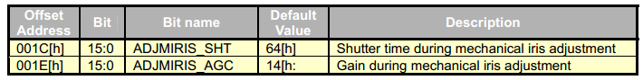

Setting Values for Mechanical Iris Voltage Adjustment

White balance control 白平衡控制
Colors seen as white under normal sunlight may appear reddish or bluish when the color temperature of the light source changes. By adjusting the Red and Blue, the correct colors can be reproduced. The function that achieves this is called white balance(WB).
白色的东西在正常日光下，随着色温的变化可能会出现偏红或是微蓝的情况。通过调整Red和Blue进行颜色重建的来实现白色的过程称为白平衡。

